**Texture Characterization of Bone Radiograph Images.**

**Application to Osteoporosis Diagnosis**

Texture Characterization of Bone radiograph images (TCB) is a challenge in the osteoporosis diagnosis.

What is Osteoporosis?

[Osteoporosis](http://www.emedicinehealth.com/slideshow_osteoporosis_pictures/article_em.htm) (Greek for “porous bone”) is a disease characterized by low bone mass and loss of bone tissue that may lead to weak and fragile bones. Osteoporosis is often called a “silent disease” because it usually progresses without any symptoms until a fracture occurs. It occurs when there is an imbalance between new bone formation and old bone resorption. The body may fail to form enough new bone, or too much old bone may be reabsorbed, or both (1).

About 54 million Americans have low bone mass, placing them at increased risk for osteoporosis. (2)

Many people think that osteoporosis is a natural and unavoidable part of aging. However, medical experts now believe that osteoporosis is largely preventable.

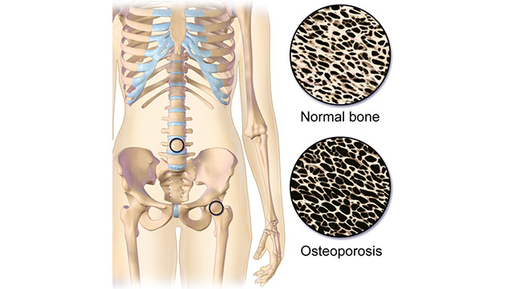  (4)

How is it determined now?

A low bone mineral density (BMD) is presently regarded as the most important risk factor for the development of osteoporosis. BMD can be estimated by the dual-energy X-ray absorptiometry [3]. However, BMD can represent only 60% fraction prediction rate.

Why our method?

Bone structure can be examined by analysing the 2D texture of conventional radiographs. The evaluation of osteoporotic disease from bone radiograph images presents a major challenge for medical Image processing and its applications. There arises difficulty in classifying textured images from the bone structure of osteoporotic and healthy subjects because of the high degree of similarity.

Objectives:

1. To identify osteoporotic subjects from healthy subjects using texture analysis on bone radiograph images. Ask Suraj for more.
2. **References:**

Other techniques like Tonal Rendering, Signal Equalization, Edge restoration, Noise Suppression, Collimation Masking, and Display Compensation might be also used depending on the data sets we acquire.

**(A review on texture analysis)**

Texture analysis:

– First order and second order methods (Second order stat features methods – Spatial greay level difference method based on analysis of co-occurrence matrix. Grey level difference and grey level run method).

* LBP methods
* Model Based approache
* Filter banks based methods – dct and dft
* Spatial filter banks and frequency analysis based approaches
* Spatial frequency based methods
* **(Bone texture characterization for osteoporosis diagnosis using digital radiography)**
* Texture Features – Fractal Dimensions, Wavelet Texture Descriptors, LBP, DFT and DCT, Law’s Texture Energy Masks, Edge Histogram, GLCM
* Feature Selection on all the textures that we have got – Correlation based FS – with BF and GA. --- Information Gain (((( cfs bf better 723 texture related characteristics – bayes network)
* Classifiers – Discriminant Functions --- Naïve Bayes – Multilayer Perceptron (feed forward) – Bayes Network – Bagging – Random Forest
* Performance metrics: True positive rate, true negative rate, classification accuracy, area under the roc curve
* *Furthermore, we plan to test feature subdomain analysis techniques to improve the separability between the two classes*

**(DIP in Radiography)**

Preprocessing techniques: ROI segmentation and analysis (since we have not got the pics yet, we have to go through them and analyse what we need to do out of these)

Tonal rendering  
Signal Equalization  
Edge restoration  
Noise Suppression   
Collimation Masking  
Display Compensation

*Tone scale processing establishes the overall image brightness and*

*global contrast*

*• Edge restoration enhances detail contrast*

*• Signal equalization extends the latitude that can be visualized while*

*maintaining detail contrast*

*• Edge restoration, signal equalization, and noise suppression are 2D*

*spatial processing*  
  
**(Fractal Analysis of Bone X-Ray Tomographic)**

Microscopy Projections

It has been validated that fractal attributes on 2-D projections are correlated

to simulations of 3-D trabecular bone changes. It remains

to more fully understand how 2-D radiographs are linked with

projections of 3-D images.

**(Texture Based Bone Radiograph for the image analysis for the assessment of osteoporosis)**

**ROI – Fractal dimensions (morphological covering method and variation method).. correlation between results from the fractal dimension and bmd amount by using dexa.**

**Indha paper la [2], retinex algorithm for preprocessing,**

**Preprocessing – filtering and then enhancement, according to this paper.**

**True false positive, true false negative, sensitivity, specificity,**

**Feature selction – Wrapper approach fischer ratio method --🡪 Feed forward neural network**

**BRODATZ(1996)—STATISTICAL – IMAGE INTENSITY DOMAIN (HISTOGRAM, COOCCURENCE MATRIX, HIGHER ORDER STATISTICS, RUN LENGTH MATRIX, GRADIENT MATRIX), MATHEMATICal MODEL PARAMETER ESTIMATION (markov random filds, autoregressive model, fractals), TRANSFORM (FOURIER TRANSFORM, GABOR FILTER, WAVELET TRANSFORM); STRUCTURAL (TEXEL); SIGNAL PROCESSING**

References:

1.(<http://www.emedicinehealth.com/osteoporosis/page2_em.htm>).

2. (<https://www.nof.org/patients/what-is-osteoporosis/>).

3. [2]  S. Hough, Fast and slow bone losers: Relevance to the management of osteoporosis, Drug Aging. 12, 1-7, 1998.

4. ( <http://www.healthline.com/health/osteoporosis#pictures4>) --- for the pic alone

5. [1]  R. Bartl, B. Frisch, Osteoporosis: Diagnosis, Prevention, Therapy, Second ed., Springer, 2009 – book

***Take union of all the parameters for the effective analysis***